

UNITEDWORLD SCHOOL OF COMPUTATIONAL INTELLIGENCE (USCI)

Summative Assessment (SA)

Submitted BY

Patel Zalak Bipinkumar

(Enrl. No.: 20220701020)

B.Sc. (Hons.) Computer Science

III Semester – July – Nov 2023

Subject: R PROGRAMMING



Nov/Dec 2023

INDEX

|  |  |  |
| --- | --- | --- |
| SR. NO. | TITLE | PAGE NO. |
|  | Introduction of the Project | 3 |
|  | Aim of the Project | 3 |
|  | Dataset Description | 4 |
|  | Step to Load Dataset | 4 to 6 |
|  | Statistical Analysis | 7 to 13 |
|  | Data Visualization | 14 to 25 |
|  | Conclusion | 26 to 27 |

**INTRODUCTION OF THE PROJECT**

* In this project of R Programming, dataset of Theoph- Pharmacokinetics of Theophylline is taken.
* Theophylline is an anti-asthmatic drug.
* Here oral doses of Theophylline were given to 12 subjects and then serum concentrations were measured 11 times over 25 hours.
* It is a high Quality Dataset with 132 rows and 5 columns.
* Statistical Analysis such as Mean, Median, Mode, Variance, Standard deviation, Quantile is performed using Theoph Dataset in R Language.
* Data Visualization using Histogram and Bar Graph is performed using Theoph data set in R studio
* Data Visualization is used to represent data in clear and visible Graphs and Structures.

**AIM OF THE PROJECT**

* To implement Statistical Analysis using Theoph Dataset in rstudio.
* The aim is to find the maximum and minimum concentration of each dose of Theophylline with respect to time using Data Visualization.

**DATASET DESCRIPTION**

* The Dataset Theoph is an experiment on the pharmacokinetics of theophylline. This dataset consist of 5 columns and 132 rows.
* 5 rows in Dataset includes:
* **Subject:** in this column of dataset there are orderd levels from 1 to 12 and it is orderd by observing maximum concentration of theophylline and it is categorized into non numeric vector.

* **Wt:** this column refers to weight of the subject in kgs.
* **Dose:** it contains information of supervision about dose of theophylline in Subject. Which is measures in milligrams and kilograms.

* **Time:** measurement of time in hours since sample was injected with theophylline.

* **conc:** concentration amount of theophylline in milligrams and litres.

**STEP TO LOAD DATASET**

INPUT:

Data(Theoph)

Output:

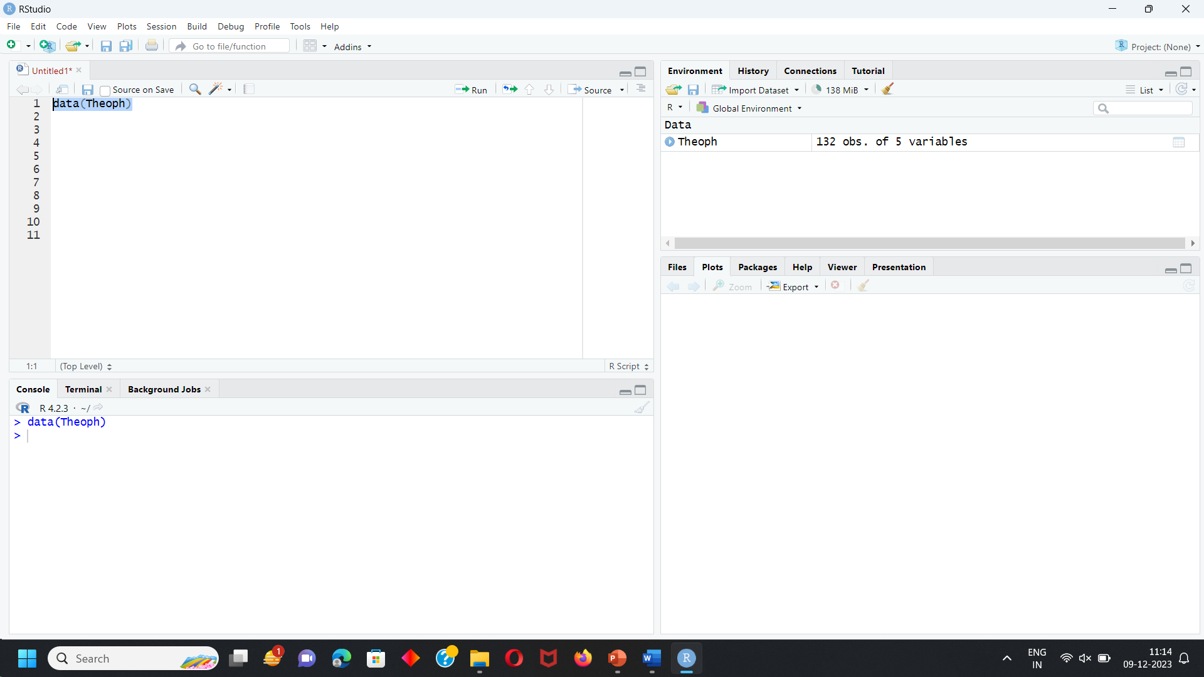

After this step data will be loaded into r workspace

To print the dataset into R:

Input:

Print(Theoph)

OUTPUT:

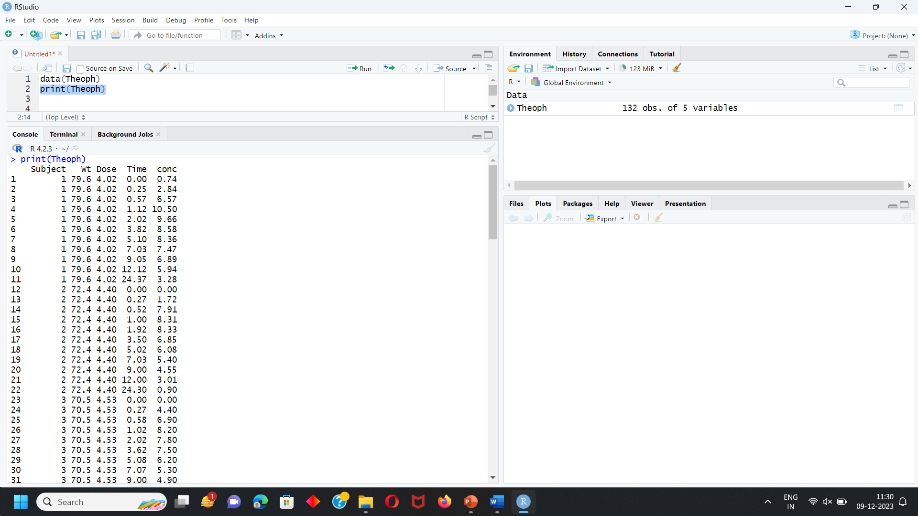

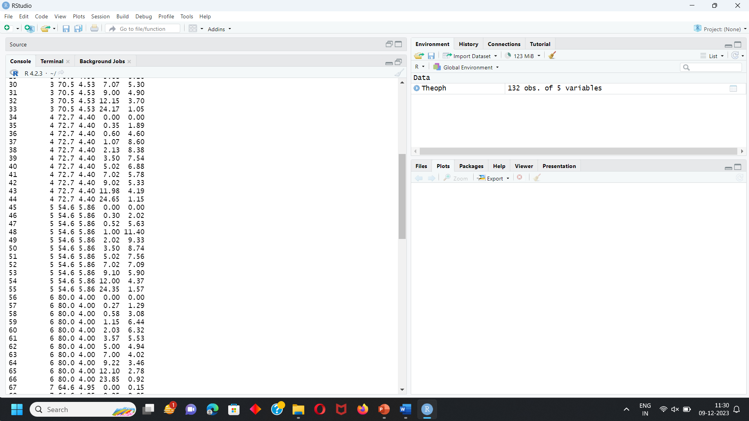

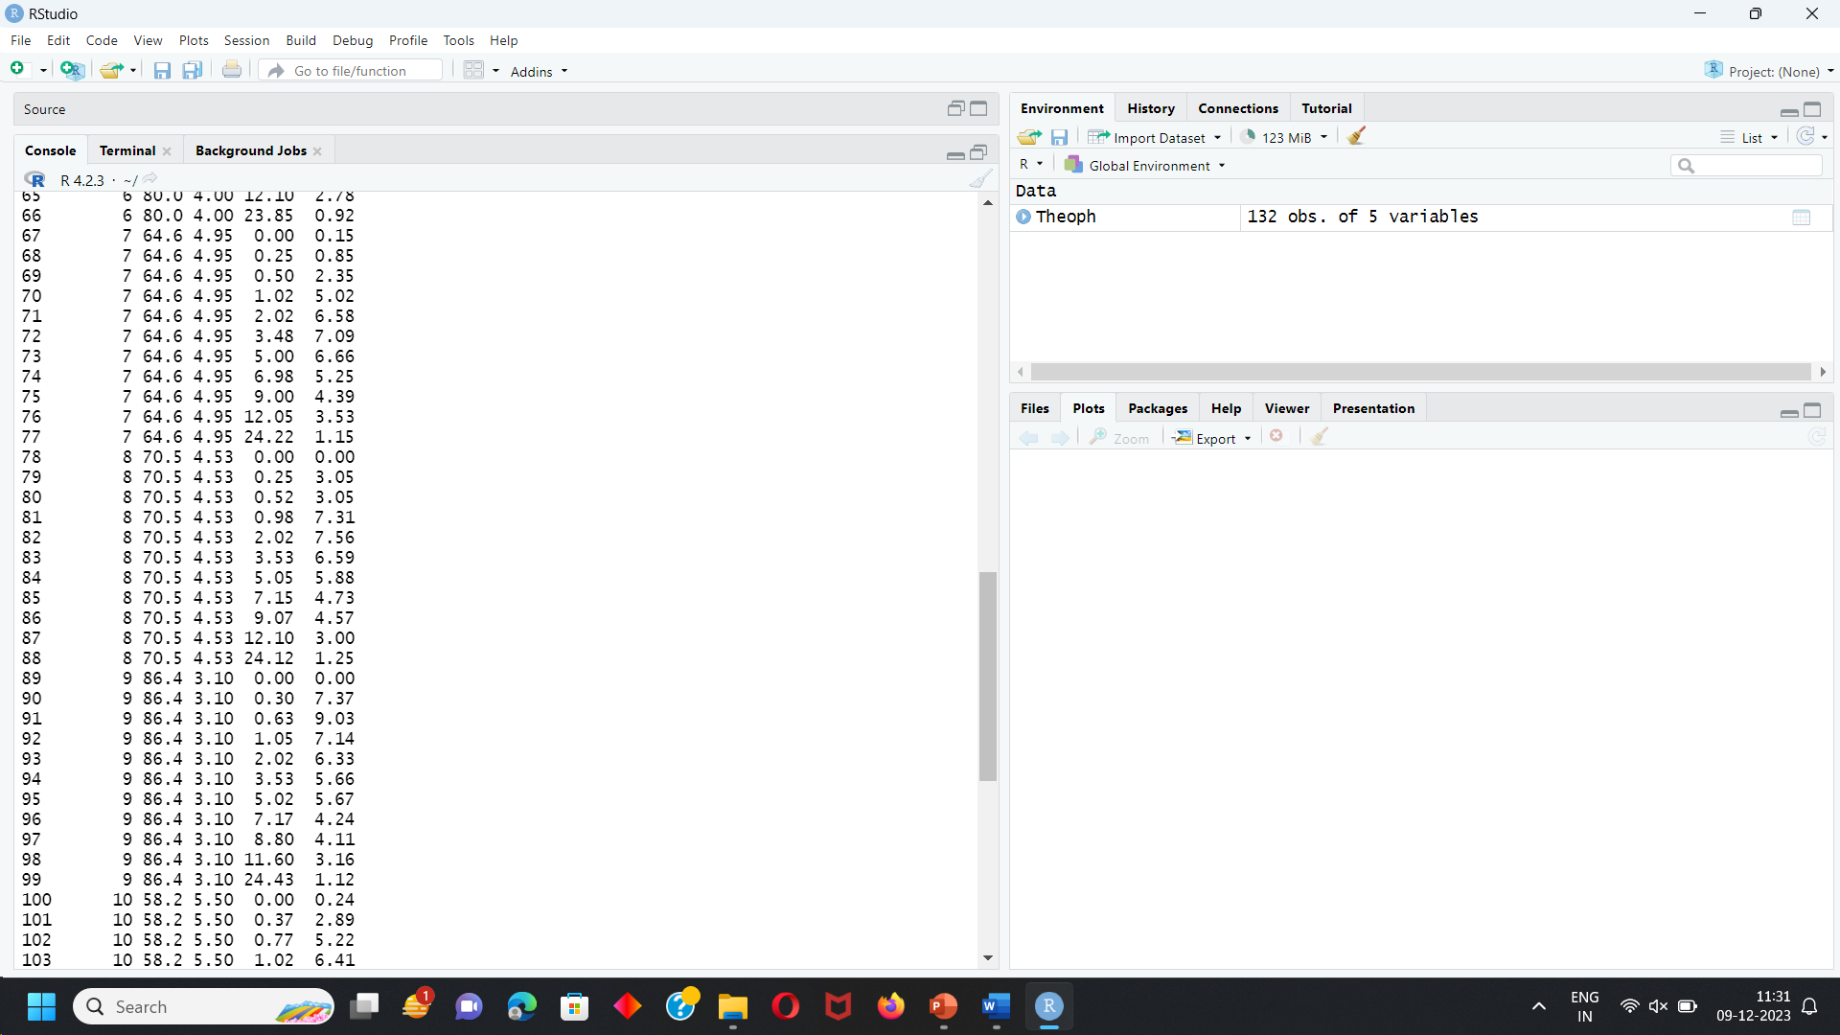

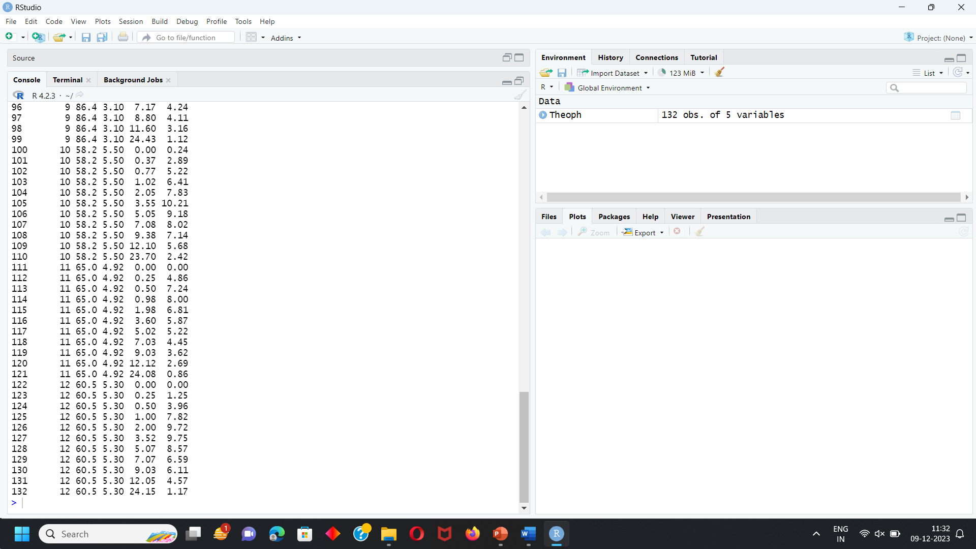

**STATISTICAL ANALYSIS**

1. MAXIMUM

* Finding Maximum for Wt, Dose, time, conc.

INPUT:

max(Theoph$Wt)

max(Theoph$Dose)

max(Theoph$Time)

max(Theoph$conc)

OUTPUT:

> max(Theoph$Wt)

[1] 86.4

> max(Theoph$Dose)

[1] 5.86

> max(Theoph$Time)

[1] 24.65

> max(Theoph$conc)

[1] 11.4

SCREENSHOT OF THE CODE:

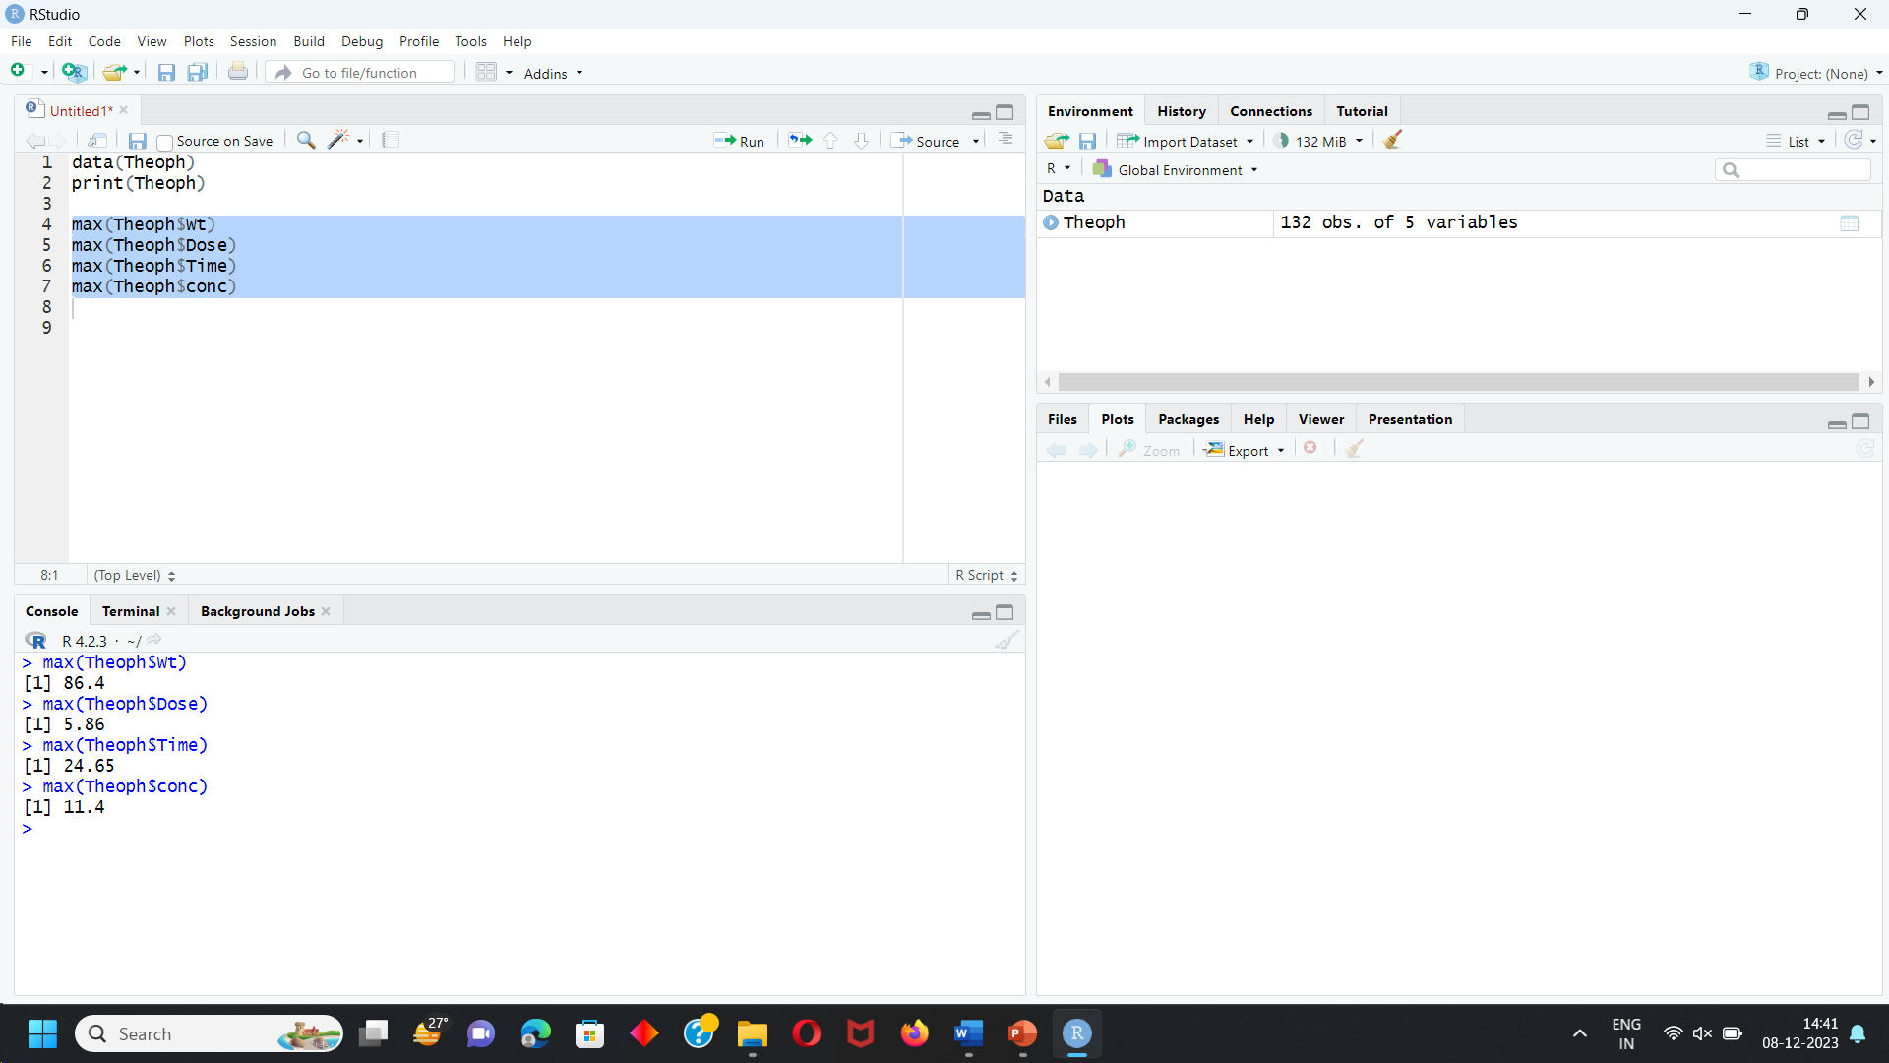

1. MINIMUM

* Finding Minimum for Wt, Dose, time, conc.

INPUT:

min(Theoph$Wt)

min(Theoph$Dose)

min(Theoph$Time)

min(Theoph$conc)

OUTPUT:

> min(Theoph$Wt)

[1] 54.6

> min(Theoph$Dose)

[1] 3.1

> min(Theoph$Time)

[1] 0

> min(Theoph$conc)

[1] 0

SCREENSHOT OF THE CODE:

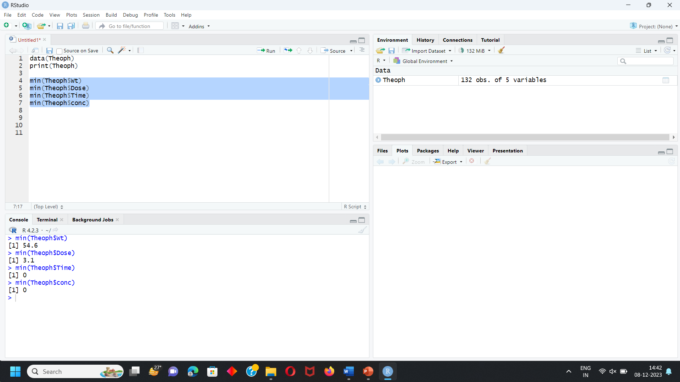

1. MEAN

* mean refers to finding average of whole dataset by adding all numbers and then dividing them with total number of dataset.
* Finding Mean for Wt, Dose, time, conc.

INPUT:

mean(Theoph$Wt)

mean(Theoph$Dose)

mean(Theoph$Time)

mean(Theoph$conc)

OUTPUT:

> mean(Theoph$Wt)

[1] 69.58333

> mean(Theoph$Dose)

[1] 4.625833

> mean(Theoph$Time)

[1] 5.894621

> mean(Theoph$conc)

[1] 4.960455

SCREENSHOT OF THE CODE:

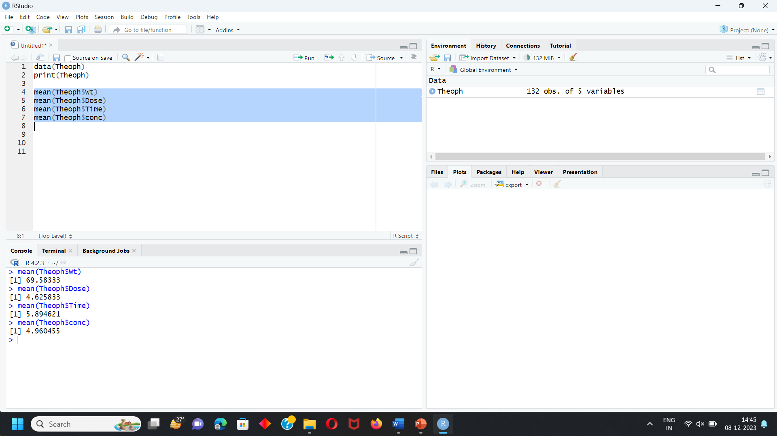

1. MEDIAN

* After ordering the data the number which arrives in middle is median.
* Finding Median for Wt, Dose, time, conc.

INPUT:

median(Theoph$Wt)

median(Theoph$Dose)

median(Theoph$Time)

median(Theoph$conc)

OUTPUT:

> median(Theoph$Wt)

[1] 70.5

> median(Theoph$Dose)

[1] 4.53

> median(Theoph$Time)

[1] 3.53

> median(Theoph$conc)

[1] 5.275

SCREENSHOT OF THE CODE:

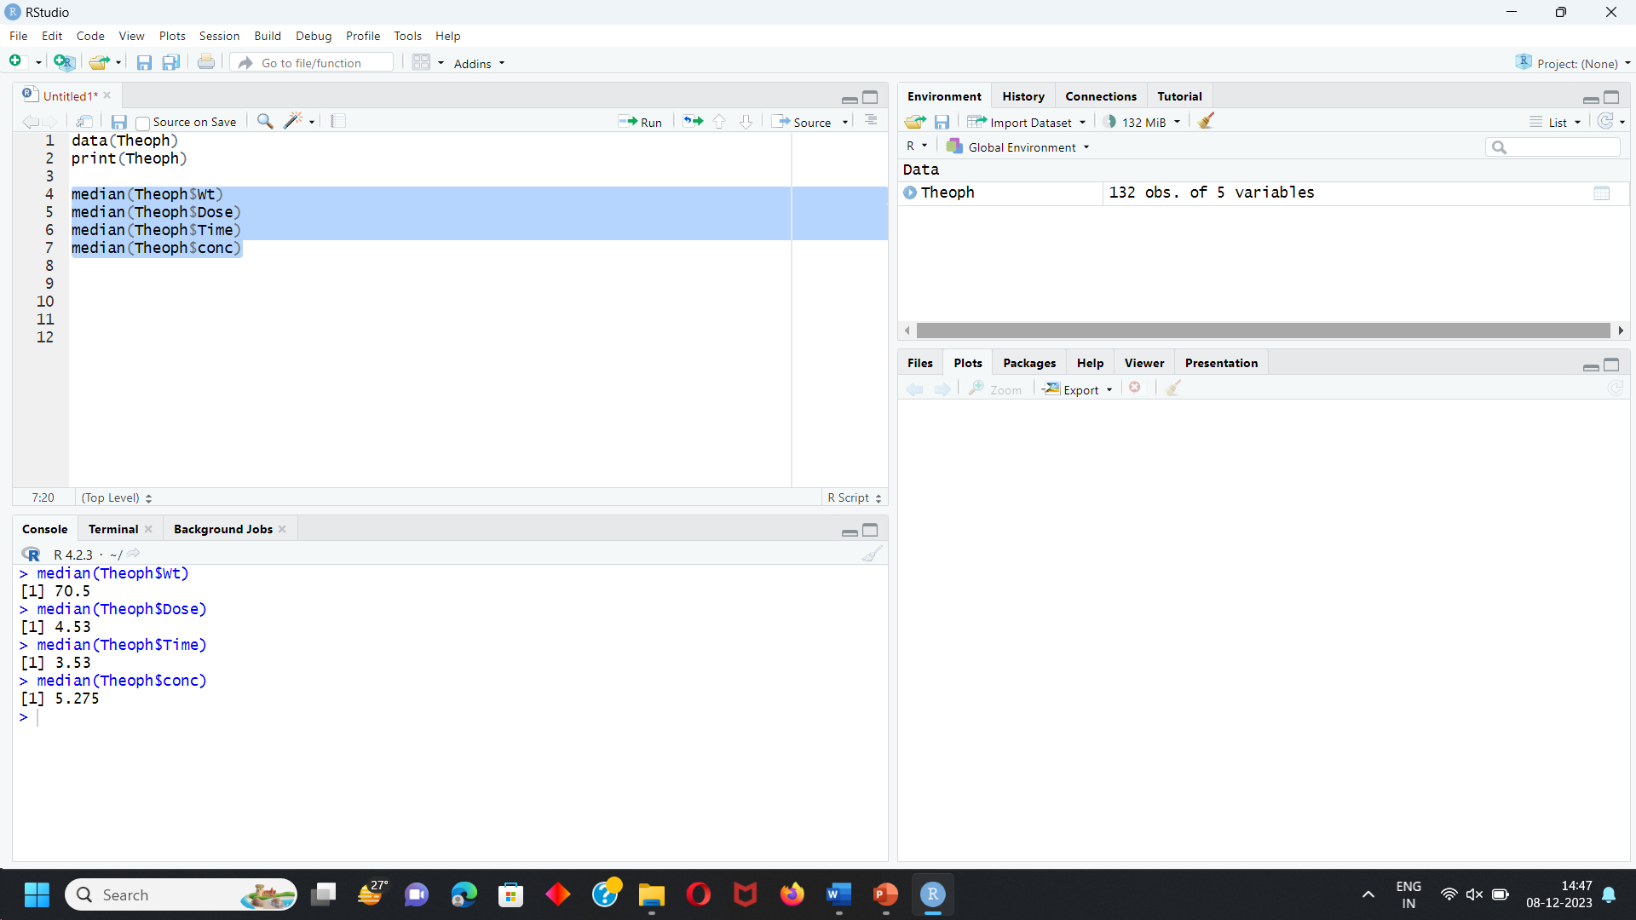

1. VARIANCE

* measurement of number which differ from mean.
* Finding Median for Wt, Dose, time, conc.

INPUT:

var(Theoph$Wt)

var(Theoph$Dose)

var(Theoph$Time)

var(Theoph$conc)

OUTPUT:

> var(Theoph$Wt)

[1] 83.41499

> var(Theoph$Dose)

[1] 0.5156306

> var(Theoph$Time)

[1] 47.96882

> var(Theoph$conc)

[1] 8.22152

SCREENSHOT OF THE CODE:

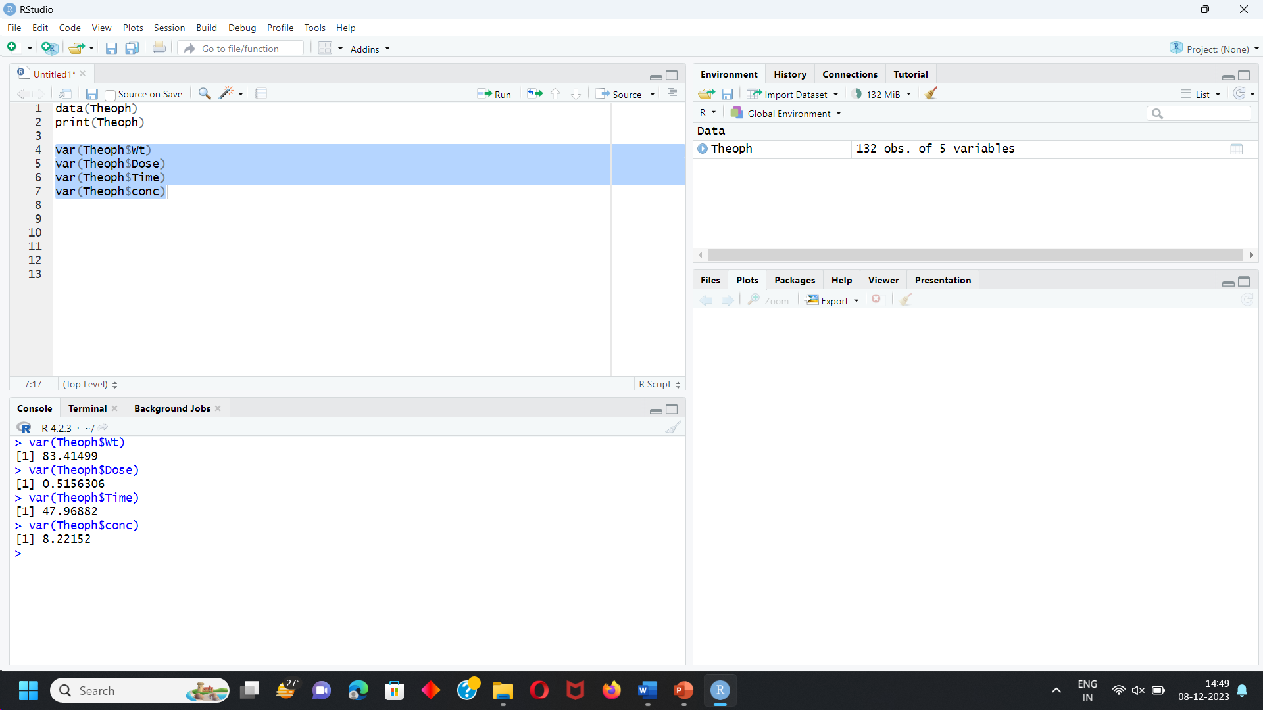

1. STANDARD DEVIATION:

* it calculates deviation of value from mean value.
* Finding Standard Deviation for Wt, Dose, time, conc.

INPUT:

sd(Theoph$Wt)

sd(Theoph$Dose)

sd(Theoph$Time)

sd(Theoph$conc)

OUTPUT:

> sd(Theoph$Wt)

[1] 9.133181

> sd(Theoph$Dose)

[1] 0.7180742

> sd(Theoph$Time)

[1] 6.925952

> sd(Theoph$conc)

[1] 2.867319

SCREENSHOT OF THE CODE:

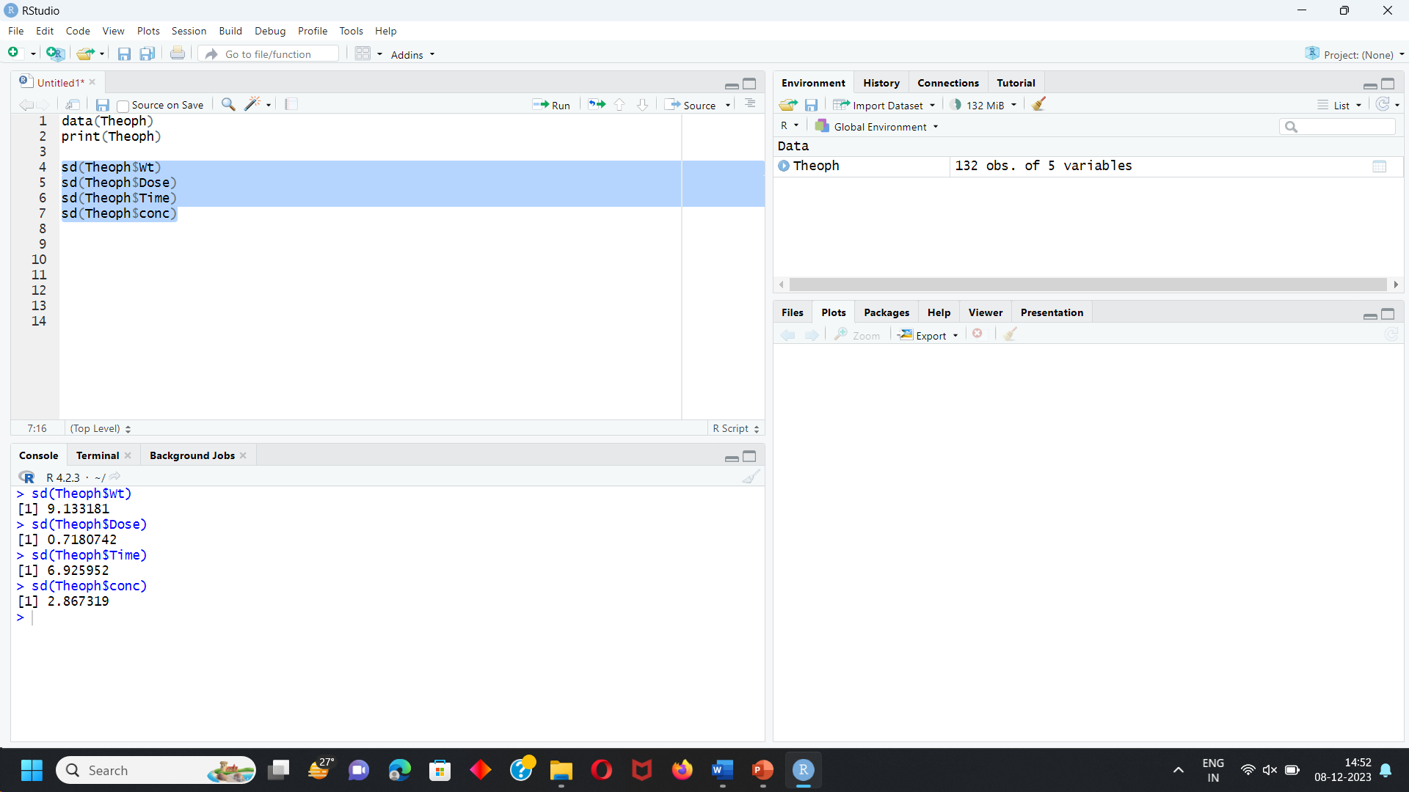

1. SUMMARY

* gives whole summary of statical analysis
* Finding Summary for Wt, Dose, time, conc.

INPUT:

summary(Theoph$Subject)

summary(Theoph$Wt)

summary(Theoph$Dose)

summary(Theoph$Time)

summary(Theoph$conc)

OUTPUT:

> summary(Theoph$Subject)

6 7 8 11 3 2 4 9 12 10 1 5

11 11 11 11 11 11 11 11 11 11 11 11

> summary(Theoph$Wt)

Min. 1st Qu. Median Mean 3rd Qu. Max.

54.60 63.58 70.50 69.58 74.42 86.40

> summary(Theoph$Dose)

Min. 1st Qu. Median Mean 3rd Qu. Max.

3.100 4.305 4.530 4.626 5.037 5.860

> summary(Theoph$Time)

Min. 1st Qu. Median Mean 3rd Qu. Max.

0.000 0.595 3.530 5.895 9.000 24.650

> summary(Theoph$conc)

Min. 1st Qu. Median Mean 3rd Qu. Max.

0.000 2.877 5.275 4.960 7.140 11.400

SCREENSHOT OF THE CODE:

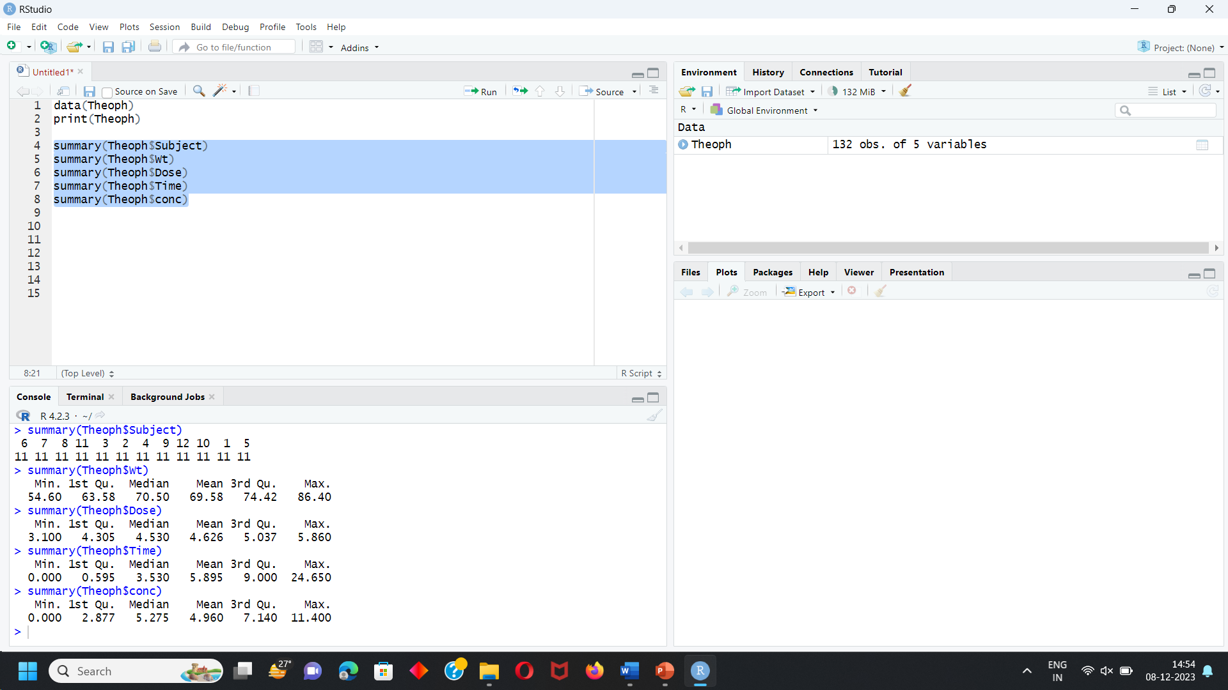

**DATA VISUALIZATION**

HISTOGRAM

Histogram for column name Dose is created.

INPUT:

hist(Theoph$Dose)

OUTPUT:

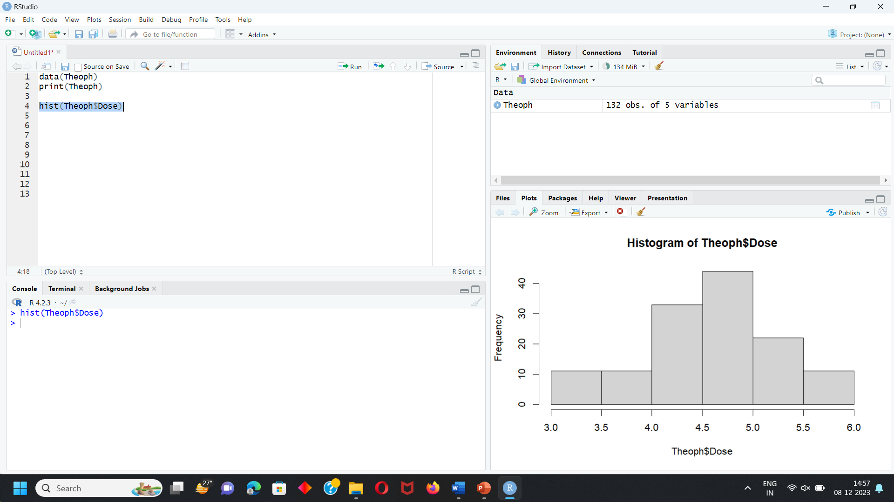

if we want to change colour of histogram and add border to represent it more clearly

Input:

hist(Theoph$Dose,col="pink",border="orange")

Output:

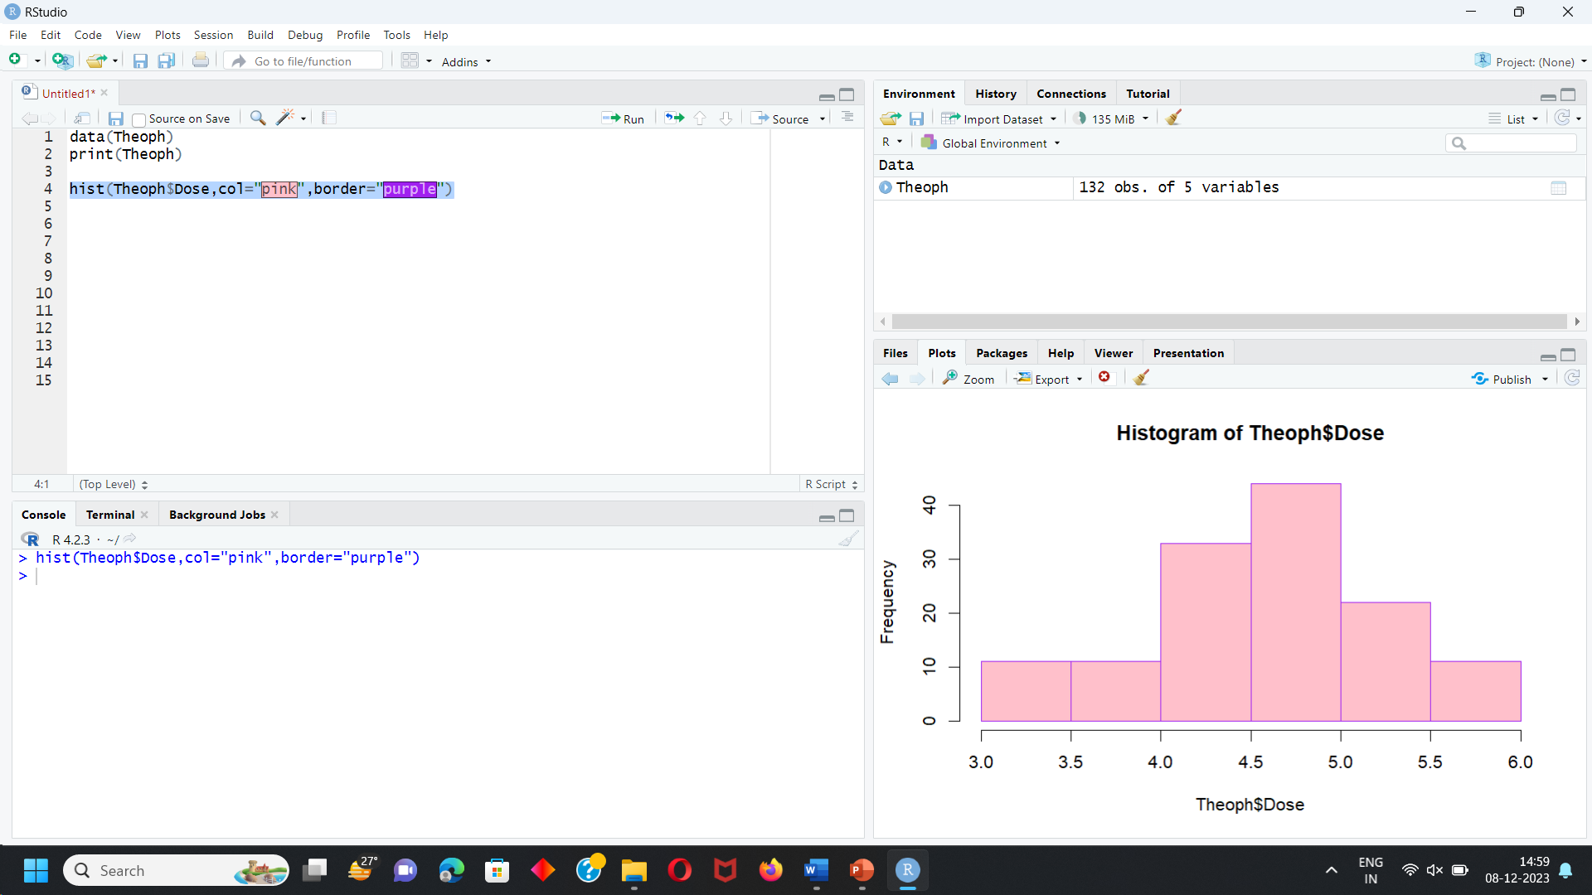

**BARGRAPH**

BARGRAPH TO EXAMINE CONC FOR DOSE 4.02 WITH RESPECT TO TIME.

Input:

barplot(Theoph$conc[Theoph$Dose == 4.02],

main="Concentration of Dose 4.02 with respect to time",

col=topo.colors(11),

xlab ="time",

ylab = "conc",

names = c("0.00","0.25","0.57","1.12","2.02","3.82","5.10",

"7.03","9.05","12.12","24.37"),cex.names=.8)

Output:

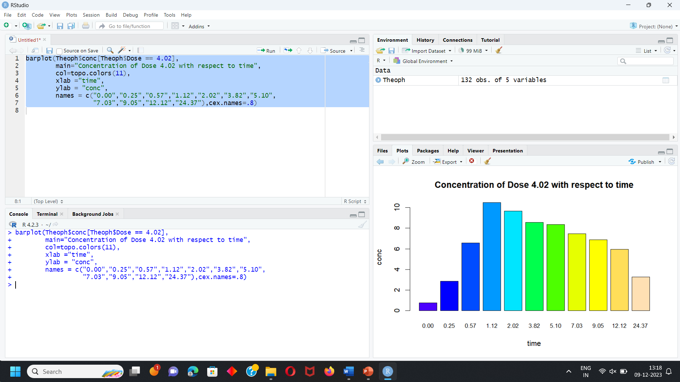

* The concentration of dose 4.02 Theophylline at different time is mentioned in bar graph.
* Maximum concentration is observed at 1.12.
* Minimum concentration is observed at 0.00.

BARGRAPH TO EXAMINE CONC FOR DOSE 4.40 WITH RESPECT TO TIME

Input:

barplot(Theoph$conc[Theoph$Dose == 4.40],

main="Measurement of conc with respect to Dose",

col=topo.colors(22),

xlab ="conc",

ylab = "Dose",

names = c("0.00","0.27","0.52","1.00","1.92","3.50","5.02",

"7.03","9.00","12.00","24.30","0.00","0.35","0.60","1.07","2.13",

"3.50","5.02","7.02","9.02","11.98","24.65"),cex.names=.10)

output:

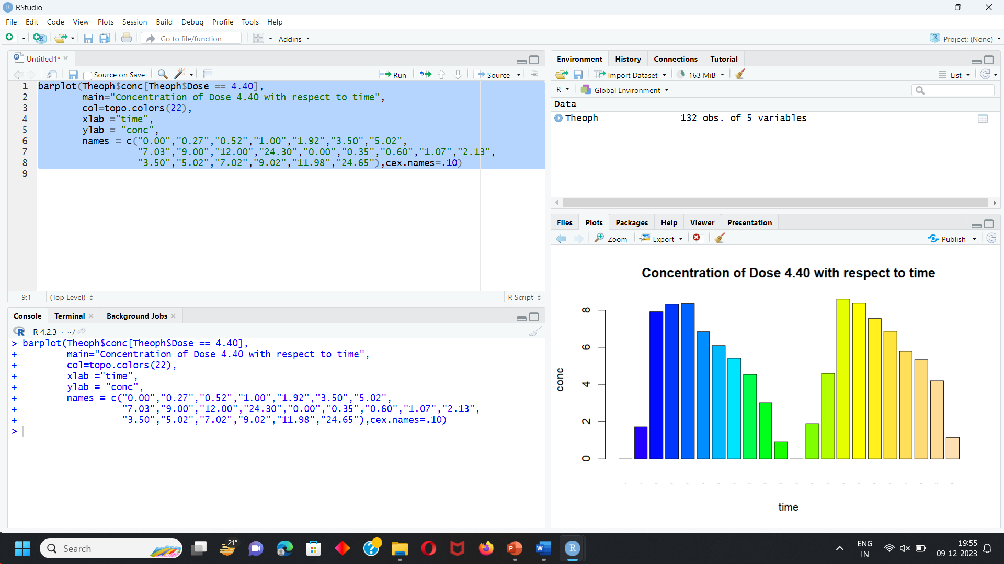

* The concentration of dose 4.40 Theophylline at different time is mentioned in bar graph.
* Maximum concentration is observed at 8.60.
* Minimum concentration is observed at 0.00.

BARGRAPH TO EXAMINE CONC FOR DOSE 4.53 WITH RESPECT TO TIME

Input:

barplot(Theoph$conc[Theoph$Dose == 4.53],

main="Concentration of Dose 4.53 with respect to time",

col=topo.colors(22),

xlab ="time",

ylab = "conc",

names = c("0.00","0.27","0.58","1.02","2.02","3.62","5.08",

"7.07","9.00","12.15","24.17","0.00","0.25","0.52","0.98","2.02",

"3.53","5.05","7.15","9.07","12.10","24.12"),cex.names=.10)

Output:

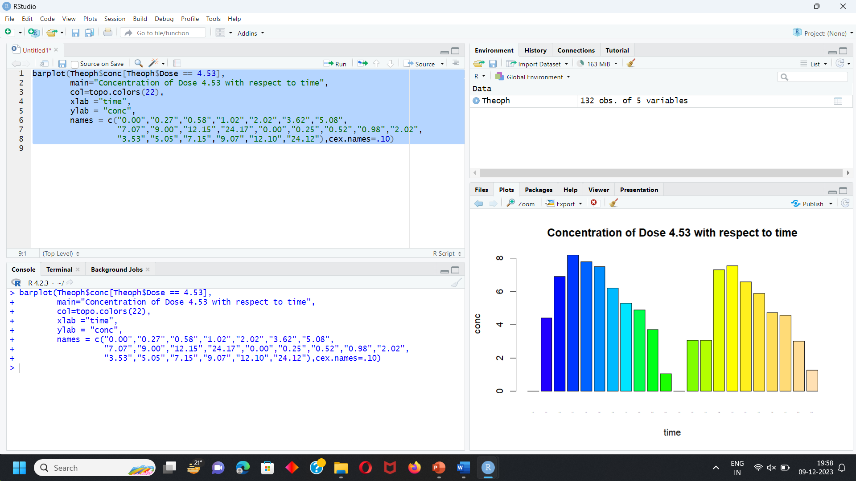

* The concentration of dose 4.53 Theophylline at different time is mentioned in bar graph.
* Maximum concentration is observed at 8.20
* Minimum concentration is observed at 0.00.

BARGRAPH TO EXAMINE CONC FOR DOSE 5.86 WITH RESPECT TO TIME

Input:

barplot(Theoph$conc[Theoph$Dose == 5.86],

main="Measurement of conc with respect to Dose",

col=topo.colors(11),

xlab ="conc",

ylab = "Dose",

names = c("0.00","0.30","0.52","1.00","2.02","3.50","5.02",

"7.02","9.10","12","24.35"),cex.names = .8)

output:

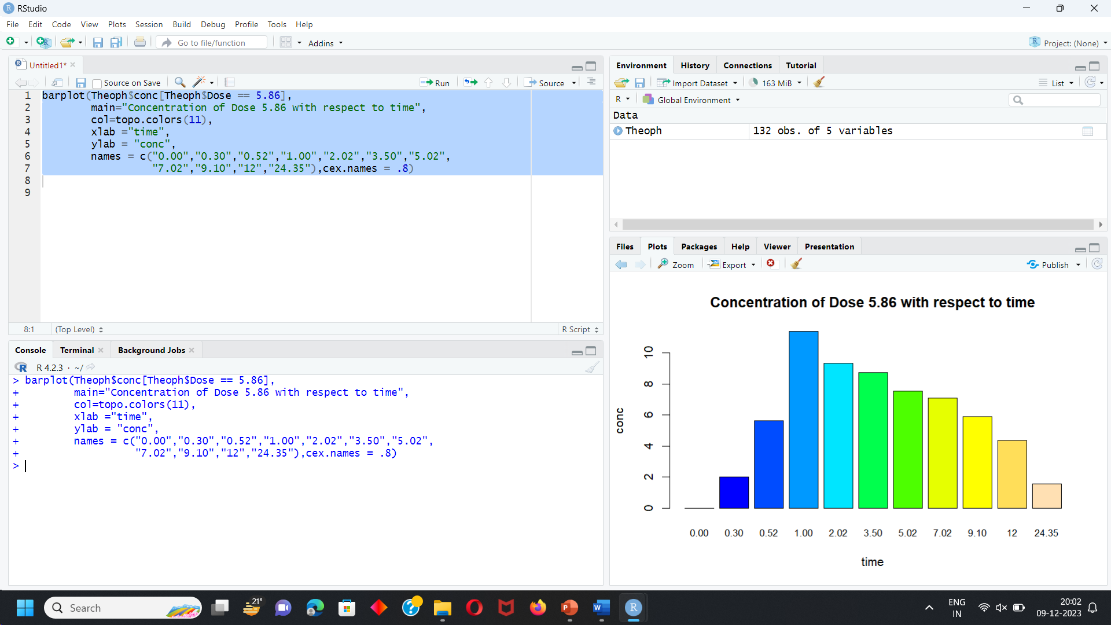

* The concentration of dose 5.86 Theophylline at different time is mentioned in bar graph.
* Maximum concentration is observed at 1.00.
* Minimum concentration is observed at 0.00.

BARGRAPH TO EXAMINE CONC FOR DOSE 4.00 WITH RESPECT TO TIME

Input:

barplot(Theoph$conc[Theoph$Dose == 4.00],

main="Concentration of Dose 4.00 with respect to time",

col=topo.colors(11),

xlab ="time",

ylab = "conc",

names = c("0.00","0.27","0.58","1.15","2.03","3.57","5.00",

"7.00","9.22","12.10","23.85"),cex.names = .8)

Output:

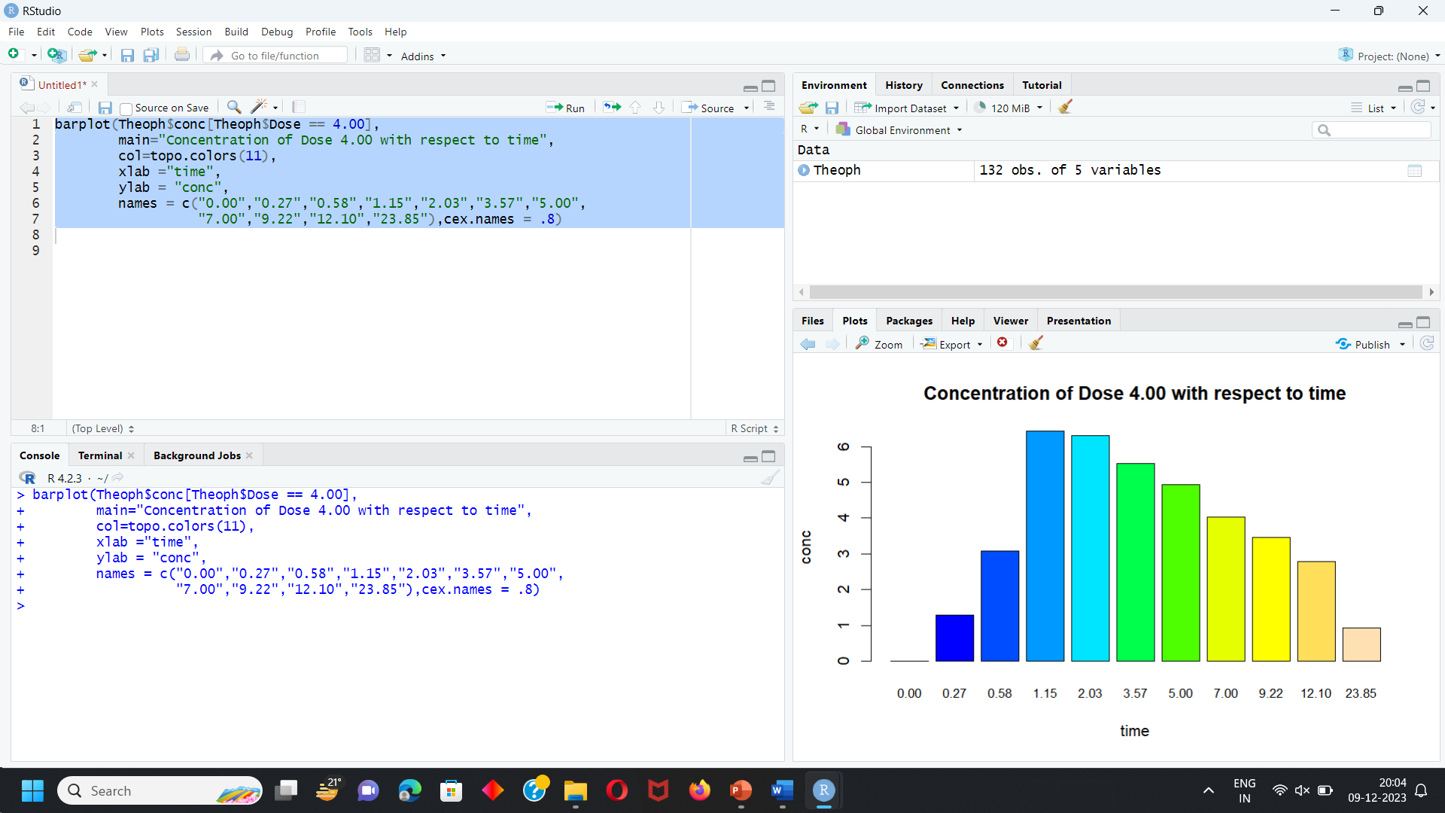

* The concentration of dose 4.00 Theophylline at different time is mentioned in bar graph.
* Maximum concentration is observed at 1.15.
* Minimum concentration is observed at 0.00.

BARGRAPH TO EXAMINE CONC FOR DOSE 4.95 WITH RESPECT TO TIME

Input:

barplot(Theoph$conc[Theoph$Dose == 4.95 ],

main=" Concentration of Dose 4.95 with respect to time ",

col=topo.colors(11),

xlab ="time",

ylab = "conc",

names = c("0.00","0.25","0.50","1.02","2.02","3.48","5.00",

"6.98","9.00","12:05","24.22"),cex.names = .8)

Output:

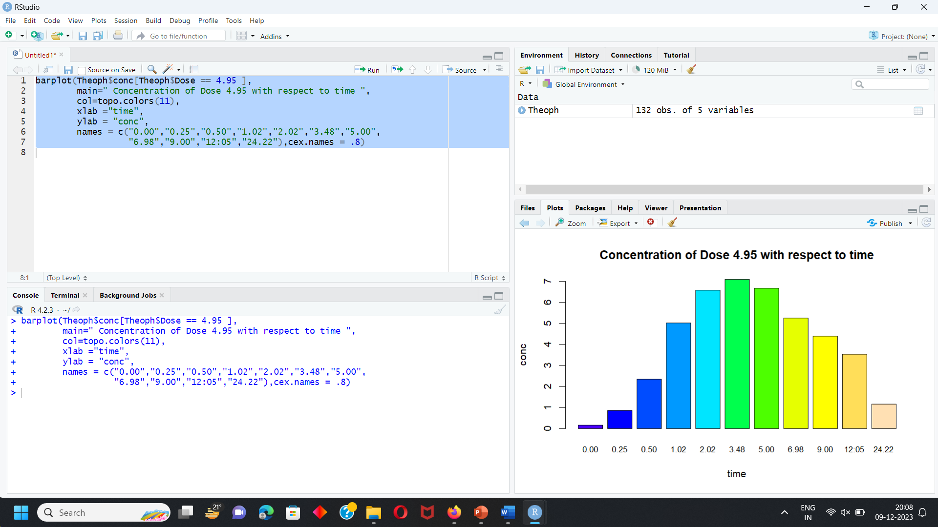

* The concentration of dose 4.95 Theophylline at different time is mentioned in bar graph.
* Maximum concentration is observed at 3.48.
* Minimum concentration is observed at 0.00.

BARGRAPH TO EXAMINE CONC FOR DOSE 3.10 WITH RESPECT TO TIME

Input:

barplot(Theoph$conc[Theoph$Dose == 3.10 ],

main=" Concentration of Dose 3.10 with respect to time ",

col=topo.colors(11),

xlab ="time",

ylab = "conc",

names = c("0.00","0.30","0.63","1.05","2.02","3.53","5.02",

"7.17","8.80","11.60","24.43"),cex.names = .8)

Output:

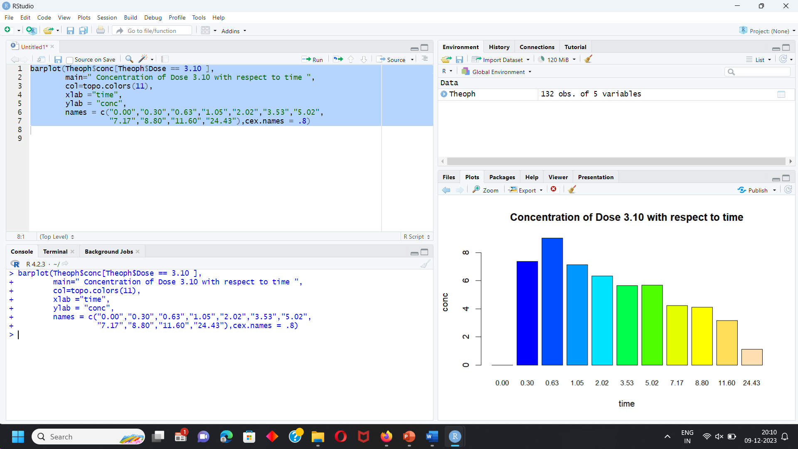

* The concentration of dose 3.10 Theophylline at different time is mentioned in bar graph.
* Maximum concentration is observed at 3.48.
* Minimum concentration is observed at 0.00.

BARGRAPH TO EXAMINE CONC FOR DOSE 5.50 WITH RESPECT TO TIME

Input:

barplot(Theoph$conc[Theoph$Dose == 5.50 ],

main=" Concentration of Dose 5.50 with respect to time ",

col=topo.colors(11),

xlab ="time",

ylab = "conc",

names = c("0.00","0.37","0.77","1.02","2.05","3.55","5.05",

"7.08","9.38","12.10","23.70"),cex.names = .8)

output:

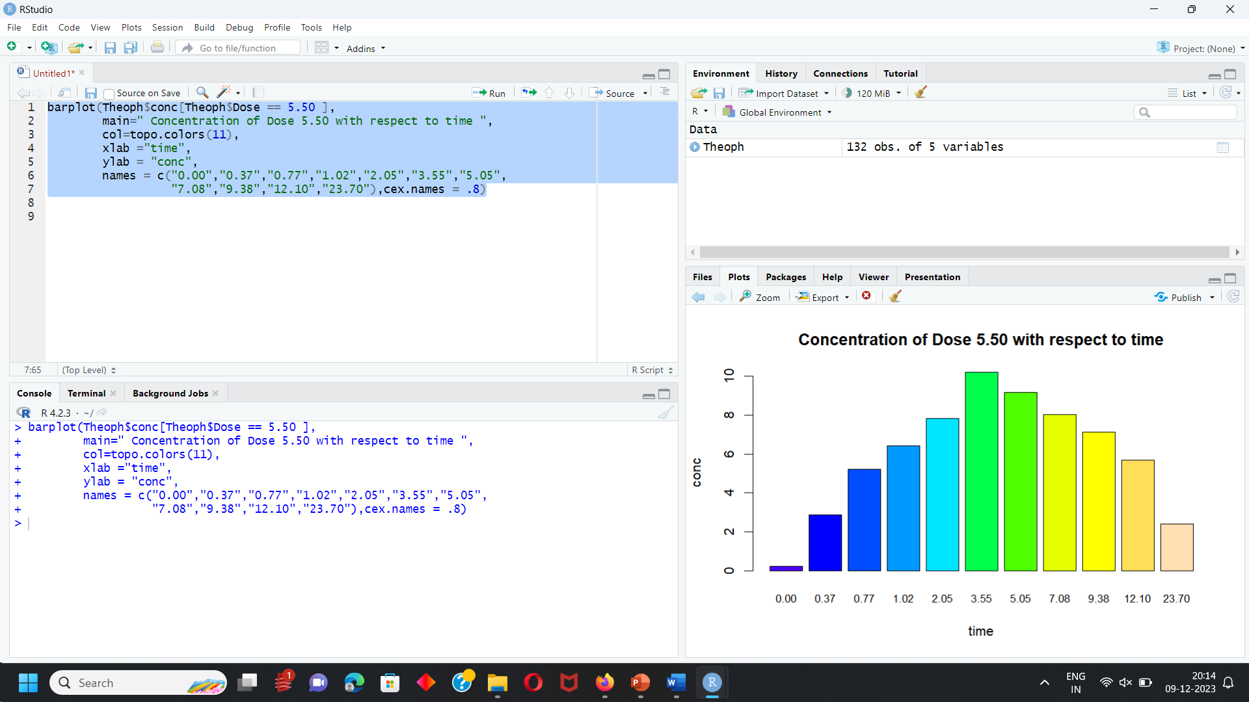

* The concentration of dose 5.50 Theophylline at different time is mentioned in bar graph.
* Maximum concentration is observed at 3.55.
* Minimum concentration is observed at 0.00.

BARGRAPH TO EXAMINE CONC FOR DOSE 4.92 WITH RESPECT TO TIME

Input:

barplot(Theoph$conc[Theoph$Dose == 4.92 ],

main=" Concentration of Dose 4.92 with respect to time ",

col=topo.colors(11),

xlab ="time",

ylab = "conc",

names = c("0.00","0.25","0.50","0.98","1.98","3.60","5.02",

"7.03","9.03","12.12","24.08"),cex.names = .8)

output:

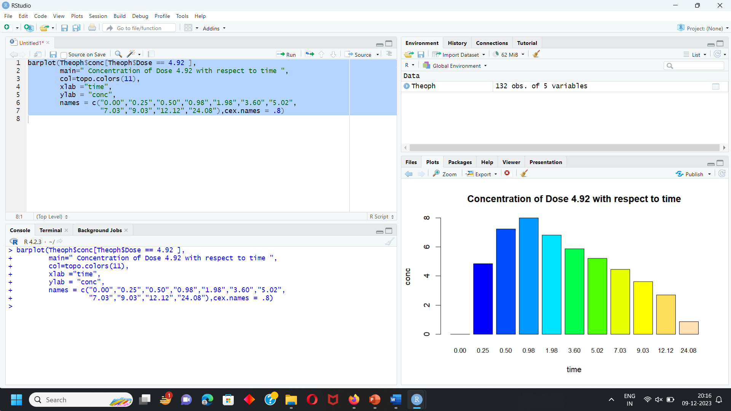

* The concentration of dose 4.92 Theophylline at different time is mentioned in bar graph.
* Maximum concentration is observed at 0.98.
* Minimum concentration is observed at 0.00.

BARGRAPH TO EXAMINE CONC FOR DOSE 5.30 WITH RESPECT TO TIME

Input:

barplot(Theoph$conc[Theoph$Dose == 5.30 ],

main=" Concentration of Dose 5.30 with respect to time ",

col=topo.colors(11),

xlab ="time",

ylab = "conc",

names = c("0.00","0.25","0.50","1.00","2.00","3.52","5.07",

"7.07","9.03","12.05","24.15"),cex.names = .8)

output:

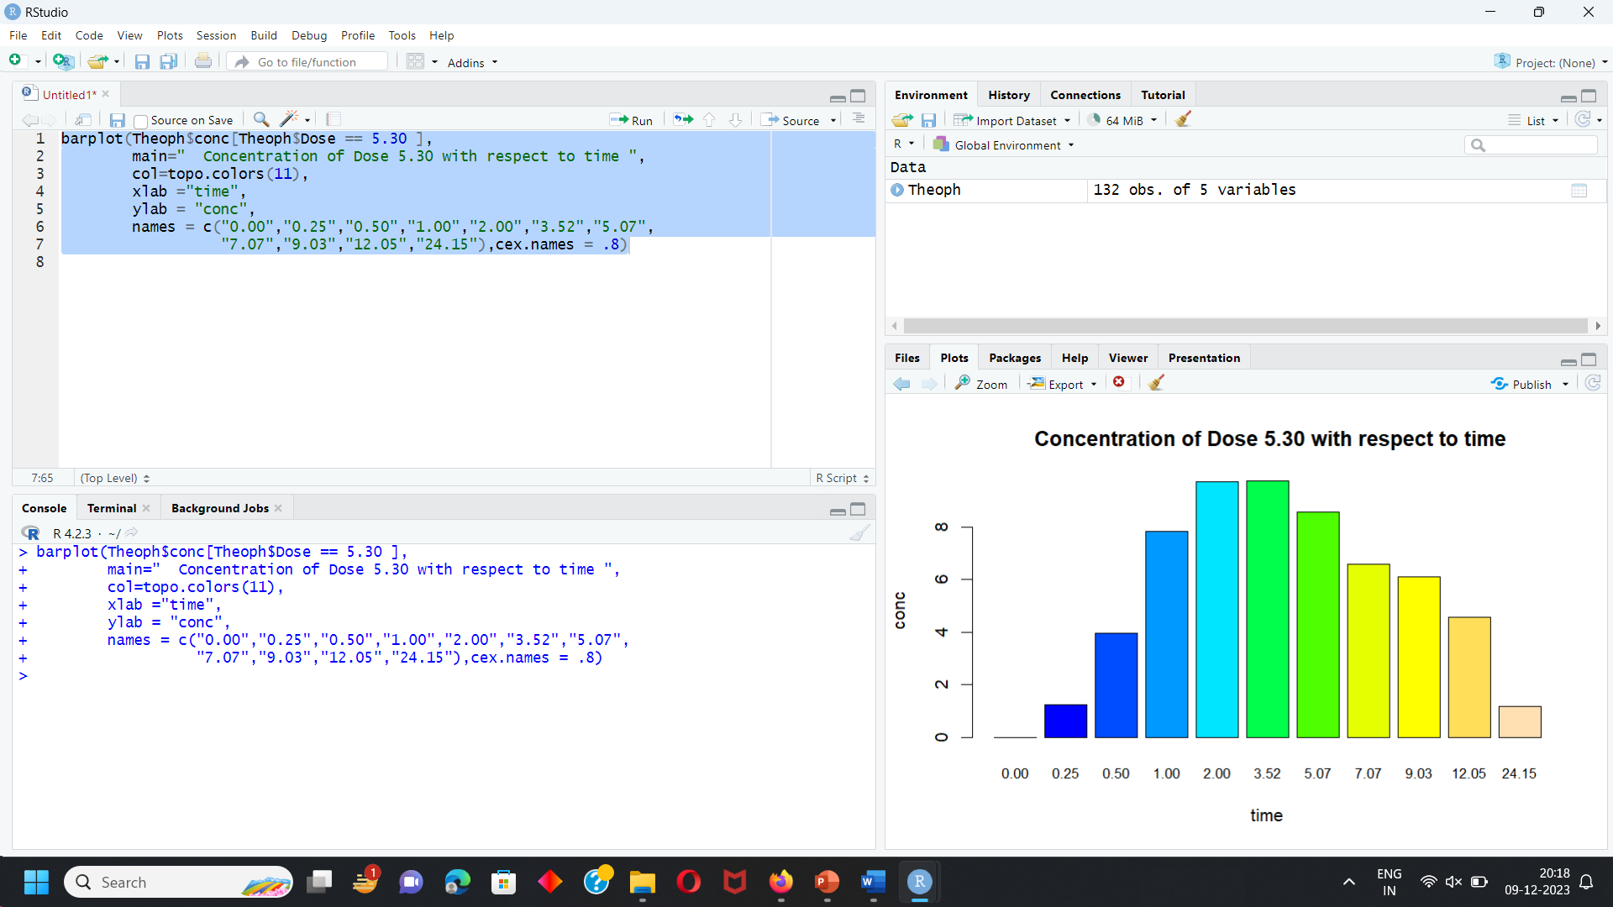

* The concentration of dose 5.30 Theophylline at different time is mentioned in bar graph.
* Maximum concentration is observed at 3.52.
* Minimum concentration is observed at 0.00.

Conclusion:

|  |  |  |
| --- | --- | --- |
| Dose | Maximum | Minimum |
| 4.02 | 1.12 | 0.00 |
| 4.40 | 8.60 | 0.00 |
| 4.53 | 8.20 | 0.00 |
| 5.86 | 1.00 | 0.00 |
| 4.00 | 1.15 | 0.00 |
| 4.95 | 3.48 | 0.00 |
| 3.10 | 0.63 | 0.00 |
| 5.50 | 3.55 | 0.00 |
| 4.92 | 0.98 | 0.00 |
| 5.30 | 3.52 | 0.00 |

**DOSE 4.02**

Maximum Concentration of Dose 4.02 is observed at time 1.12.

Minimum Concentration of Dose 4.02 is observed at time 0.00.

**DOSE 4.40**

Maximum Concentration of Dose 4.40 is observed at time 8.60.

Minimum Concentration of Dose 4.40 is observed at time 0.00.

**DOSE 4.53**

Maximum Concentration of Dose 4.53 is observed at time 8.20.

Minimum Concentration of Dose 4.53 is observed at time 0.00.

**DOSE 5.86**

Maximum Concentration of Dose 5.86 is observed at time 1.00.

Minimum Concentration of Dose 5.86 is observed at time 0.00.

**DOSE 4.00**

Maximum Concentration of Dose 4.00 is observed at time 1.15.

Minimum Concentration of Dose 4.00 is observed at time 0.00.

**DOSE 4.95**

Maximum Concentration of Dose 4.95 is observed at time 3.48.

Minimum Concentration of Dose 4.95 is observed at time 0.00.

**DOSE 3.10**

Maximum Concentration of Dose 3.10 is observed at time 0.63.

Minimum Concentration of Dose 3.10 is observed at time 0.00.

**DOSE 5.50**

Maximum Concentration of Dose 5.50 is observed at time 3.55.

Minimum Concentration of Dose 5.50 is observed at time 0.00.

**DOSE 4.92**

Maximum Concentration of Dose 4.92 is observed at time 0.98.

Minimum Concentration of Dose 4.92 is observed at time 0.00.

**DOSE 3.50**

Maximum Concentration of Dose 5.30 is observed at time 3.52.

Minimum Concentration of Dose 5.30 is observed at time 0.00.

* Maximum Concentration from all Doses is 8.60.
* Minimum Concentration from all Doses is 0.00.